**Electricity price:** 23.03 US cent/kWh.

**Wind:**

Average diameter of wind mill is 50m, therefore, the area of wind will = 25*25*3.14 = 1962m^2 Annual profit = **0.5kWh/m^2(input)** * **1962m^2 (area input)** * 23.03 cent/kWh * 24h/day * 365 day/year = 1.9 million USD

**Solar:**

Solar energy/ m^2 : **3.92kwh/day (input)**

Energy: 3.92 * 365 = 1430.8 kwh

Price/m^2 : 1430.8 * 23.03 = 32951.324 usd

Annual profit = 32951.324 * **Area selected (input)**

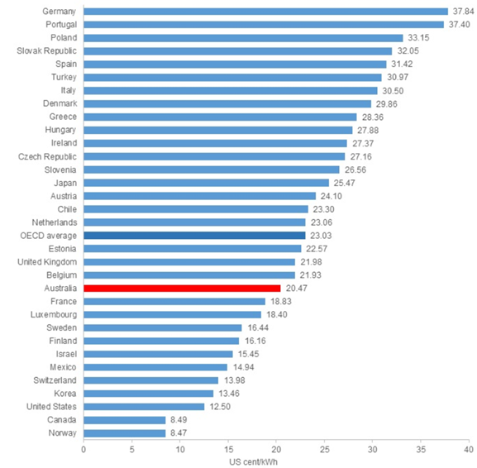

**Cost for wind energy**

Based on the installation cost in 2018, the price for the wind turbine is 1.03USD Million/mkW

Shows global average pricing for turbines by delivery date (solid line) and the pricing reported in the previous, 2H 2016 Wind Turbine Price Index (dashed line), expressed in million dollars per megawatt.

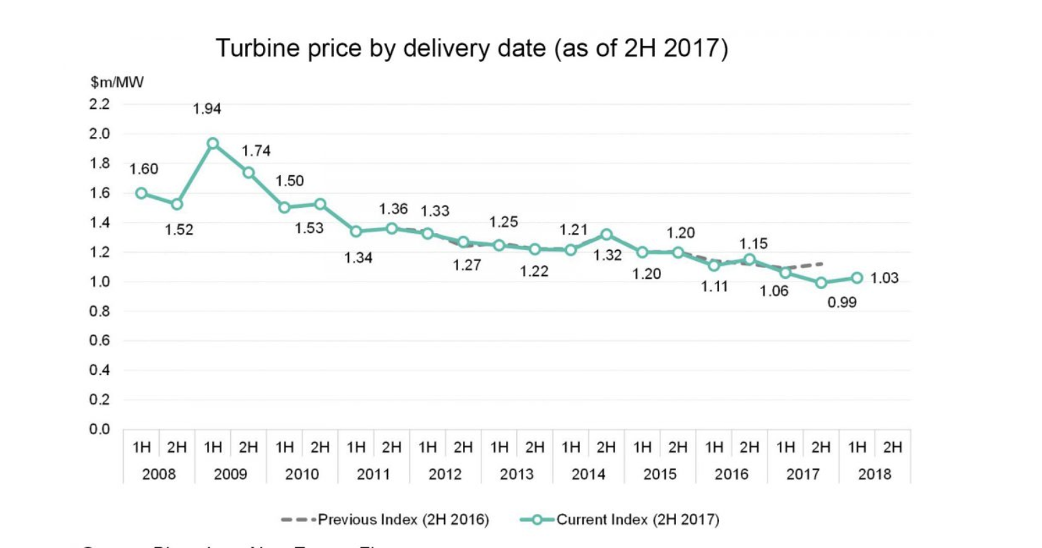

Reference

<https://about.bnef.com/blog/2h-2017-wind-turbine-price-index/>

<https://www.irena.org/documentdownloads/publications/re_technologies_cost_analysis-wind_power.pdf>

The costs for a utility scale wind turbine range from about $1.3 million to $2.2 million per MW of nameplate capacity installed. Most of the commercial-scale turbines installed today are 2 MW in size and cost roughly $3-$4 million installed.

So, 3.5million is selected as average **installation cost.**

References: <http://www.windustry.org/how_much_do_wind_turbines_cost>

The median operations **and** maintenance (O&M) cost **for** a U.S. utility-scale **wind** farm with a full **wrap** guarantee was just over $48,000/MW in 2016

Thus, **maintenance cost** = 48000/MW * 2MW= $96000/year

References: <http://newenergyupdate.com/wind-energy-update/us-wind-om-costs-estimated-48000mw-falling-costs-create-new-industrial-uses-iea>

ROI for wind energy/m^2 = return/investment

= return/3.5million

= ((1.9 MUSD - maintenance fee) * number of years - 3.5million)/3.5m

= ((1.9 MUSD - 96000)* number of years - 3.5million)/3.5m

Around 4 years.

Note: input is wind energy generated

**(if possible, please include the price of conducted material, labour cost)**

**Cost for solar energy**

Installation fee:

The average price per watt for solar panels ranges from $2.67 to $3.43, and solar panel costs for an average-sized installation in the U.S. usually range from $11,214 to $14,406 after solar tax credits.

So installation fee gets the average of $12810

**Reference:** [**https://news.energysage.com/how-much-does-the-average-solar-panel-installation-cost-in-the-u-s/**](https://news.energysage.com/how-much-does-the-average-solar-panel-installation-cost-in-the-u-s/)

**Maintenance cost:**

$150 per year

<https://reneweconomy.com.au/hidden-cost-of-rooftop-solar-who-should-pay-for-maintenance-99200/>

ROI for solar energy/m^2 = return/investment

= (((**energy/ m^2 (input)**\*365*23.03)\***area size(input)** - maintenance fee * **area size(input)) \*** number of year -12810) / $12810

Annual profit = **energy/ m^2 (input)**\*365*23.03)\***area size(input)** **\*** number of year

Net profit = (((**energy/ m^2 (input)**\*365*23.03)\***area size(input)** - maintenance fee * **area size(input)) \*** number of year -12810)

ROI = Net profit / 12810